
NOTICE OF PROPOSAL
ROAD TRAFFIC REGULATION ACT 1984
LANCASHIRE COUNTY COUNCIL
(IRWELL VALE ROAD, AITKEN STREET, BOWKER STREET AND MILNE STREET, IRWELL VALE, ROSSENDALE BOROUGH) (PART-REVOCATION AND WEIGHT RESTRICTION) ORDER 201*

NOTICE IS HEREBY GIVEN that Lancashire County Council propose to make the above Traffic Regulation Order under Sections 1, 2 and 4 of and Part IV of Schedule 9 to the Road Traffic Regulation Act 1984, as amended, the effect of which will be to:

- Revoke "The Lancashire County Council (Private Bridges at Irwell Vale, Rossendale Borough) (Weight Restriction) Order 1996" insofar as it relates to:
  - The lengths of Irwell Vale Road, Irwell Vale, carried by Ogden Bridge;
  - The lengths of Aitken Street, Irwell Vale, carried by Irwell Vale Bridge.

- Introduce an 18 tonnes weight restriction in the following lengths of road:
  - Aitken Street, Irwell Vale, from its north western end to a point 85 metres south east of its junction with the centre line of Ogden Bridge;
  - Bowker Street, Irwell Vale, for its entire length;
  - Milne Street, Irwell Vale, for its entire length;
  - Irwell Vale Road, Irwell Vale, from the centre line of Aitken Street for a distance of 21 metres in a north easterly direction.
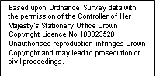
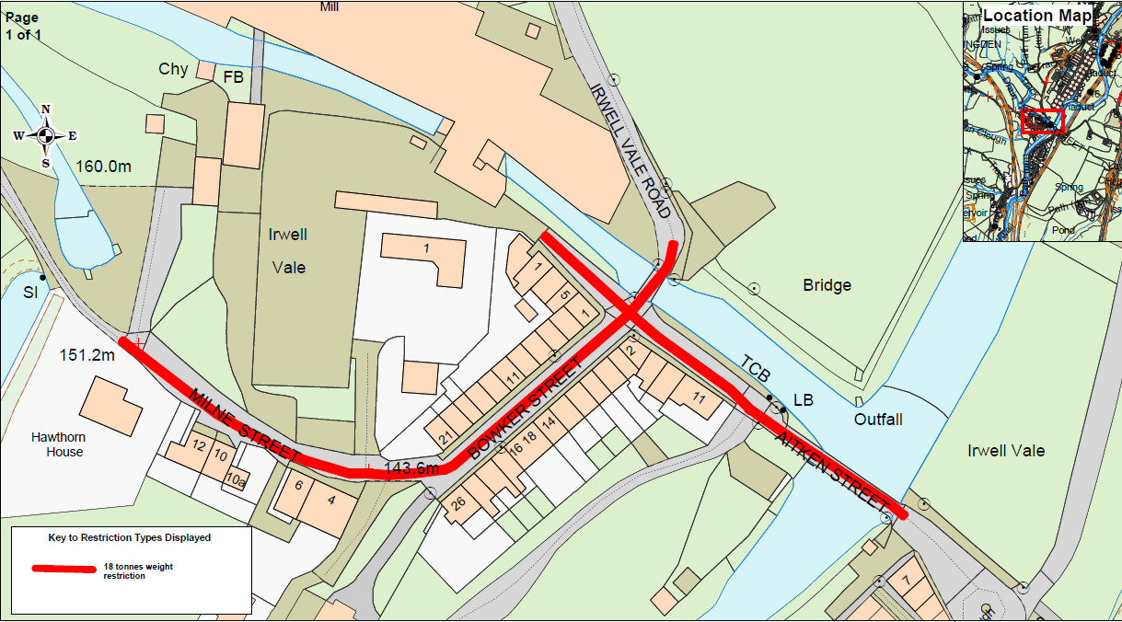

Statement of Reasons

Two private bridges at Irwell Vale have been strengthened: Ogden Bridge and Irwell Vale Bridge. They are currently subject to a 7.5t structural weight limit. As the bridges are now capable of carrying 40t vehicles the structural weight limit is no longer appropriate.

An environmental weight limit is appropriate to prevent damage by large vehicles to the privately maintained road network in the village.

Lumb Bridge has not been strengthened and will remain subject to a 7.5t structural weight limit.

It is intended to sign only the entry to the weight restricted area (at the north east side of Ogden Bridge) as there are no other entry points capable of use by vehicles over 18t. This will avoid having unnecessary signs in the conservation area.

A copy of the draft Order and associated documents for proposing to make the Order may be inspected during normal office hours at the offices of Rossendale Borough Council - One Stop Shop, The Business Centre, Futures Park, Newchurch Road, Bacup, Lancashire, OL13 0BB and at the offices of the Director of Corporate Services, Lancashire County Council, Christ Church Precinct, County Hall, Preston, Lancashire, PR1 8XJ, and on Lancashire County Council's website http://www.lancashire.gov.uk/roads-parking-and-travel/roads/roadworks-and-traffic-regulation-orders/permanent.aspx. Any representations or objections (specifying the grounds on which they are made) relating to the proposal must be made in writing and should be sent to the Director of Corporate Services, Lancashire County Council, PO Box 78, County Hall, Preston, Lancashire, PR1 8XJ or by e-mail to tro-consultation@lancashire.gov.uk quoting ref:LSG4\894.6625\ML2 before the 06 July 2018.

Laura Sales, Director of Corporate Services
08 June 2018

